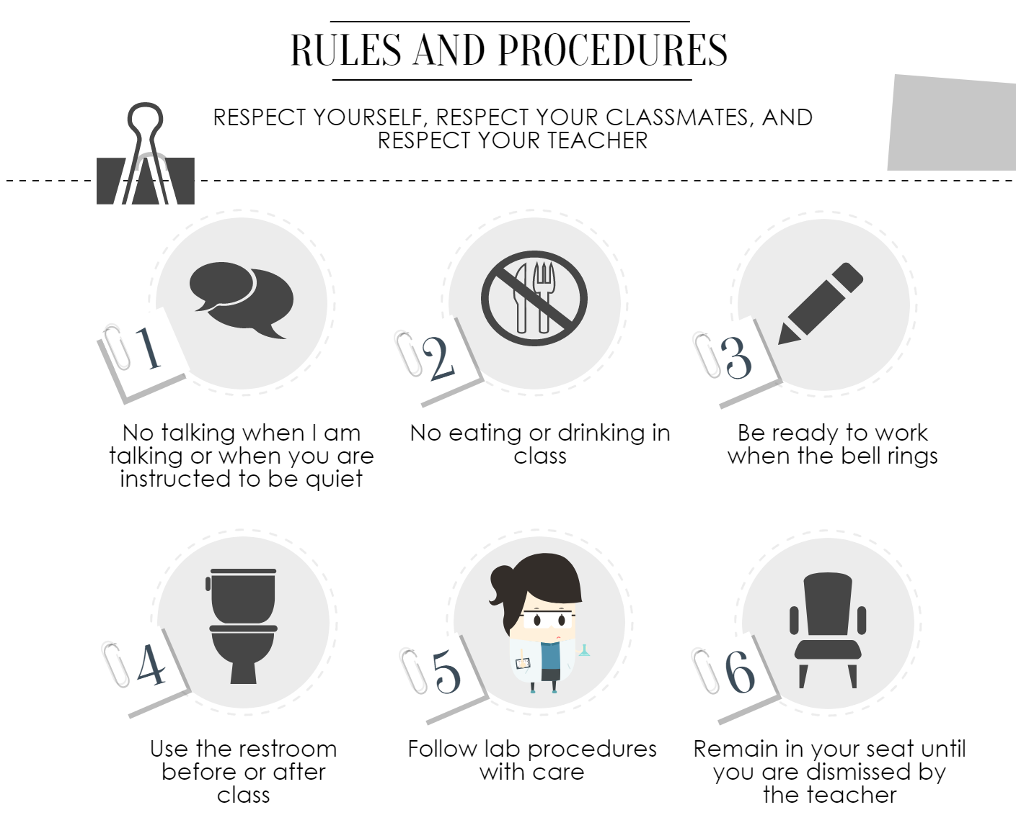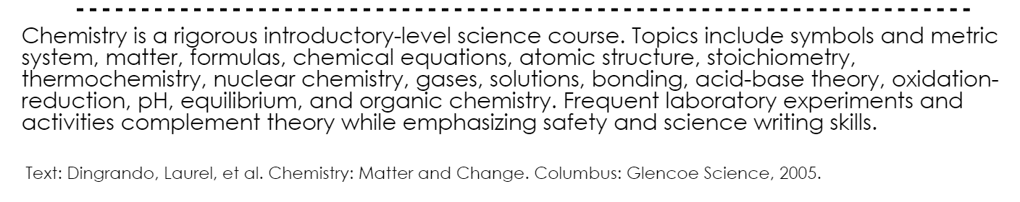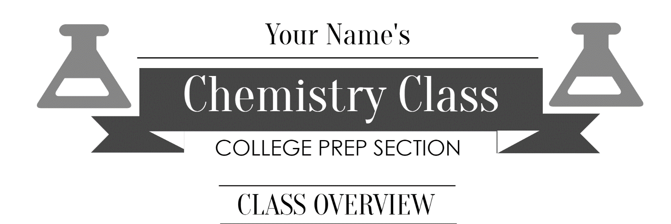

Follow lab procedures with care

Remain in your seat until you are dismissed by the teacher

Use the restroom before or after class

No eating or drinking in class

Be ready to work when the bell rings

No talking when I am talking or when you are instructed to be quiet

RESPECT YOURSELF, RESPECT YOUR CLASSMATES, AND RESPECT YOUR TEACHER

RULES AND PROCEDURES

Chemistry is a rigorous introductory-level science course. Topics include chemical symbols, the metric system, matter, chemical formulas, chemical equations, atomic structure, stoichiometry, thermochemistry, nuclear chemistry, gases, solutions, bonding, acid-base theory, oxidation-reduction, pH, equilibrium, and organic chemistry. Frequent laboratory experiments and activities complement theory while emphasizing safety and science writing skills.

Text: Dingrando, Laurel, et al. Chemistry: Matter and Change. Columbus: Glencoe Science, 2005.

YOUR CLASSROOM HELPER’S

CLASS OVERVIEW

COLLEGE PREP SECTION

Chemistry Class

Your Name

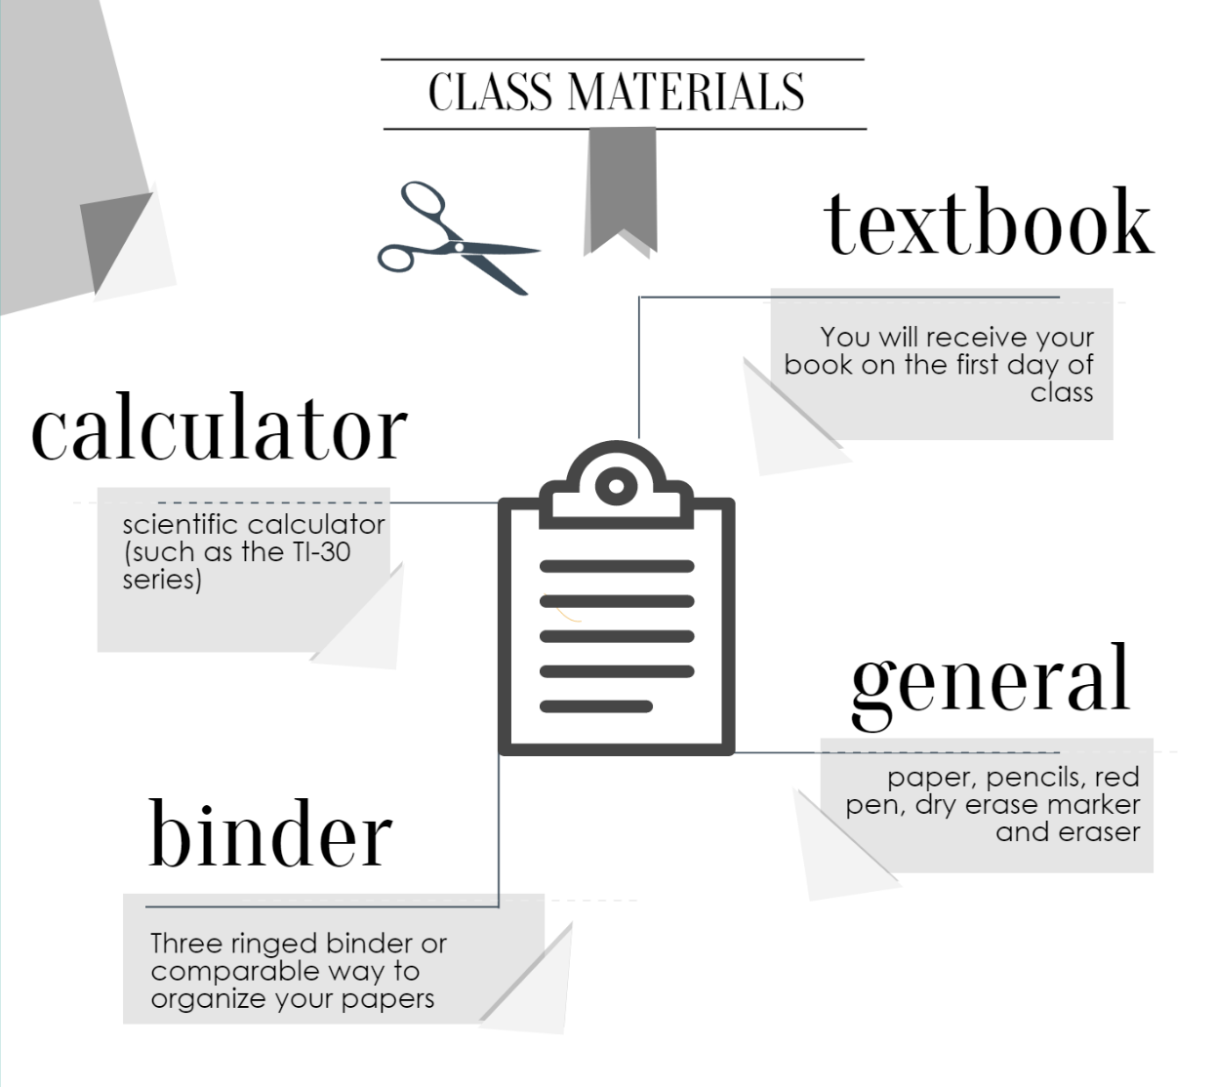

CLASS MATERIALS

textbook

general

binder

calculator

Scientific calculator (such as the TI-30 series)

You will receive your book on the first day of class

Paper, pencils, red pen, dry erase marker and eraser

Three ringed binder or comparable way to organize your papers

REMEMBER: YOU ARE RESPONSIBLE FOR YOUR ACTIONS AND ALL SCHOOL RULES APPLY AT ALL TIMES



GRADES AND ASSIGNMENTS

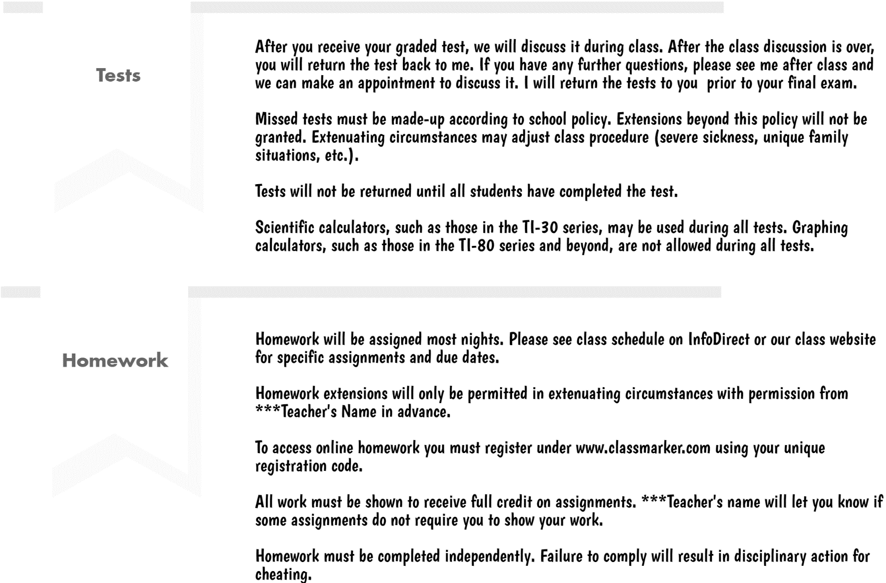

Homework will be assigned most nights. Please see the class schedule on InfoDirect or on our class website for specific assignments and due dates.

Homework extensions will only be permitted in extenuating circumstances with permission from \*\*\*Teacher’s name\*\*\* in advance.

To access online homework, you must register under www.classmarker.com using your unique registration code.

All work must be shown to receive full credit on assignments. \*\*\*Teacher’s name\*\*\* will let you know if some assignments do not require you to show your work.

Homework must be completed independently. Failure to comply will result in disciplinary action for cheating.

After you receive your graded test, we will discuss it during class. After the class discussion is over, you will return the test back to me. If you have any further questions, please see me after class and we can make an appointment to discuss it. I will return the test to you prior to your final exam

Missed tests must be made-up according to school policy. Extensions beyond this policy will not be granted. Extenuating circumstances may adjust class procedure (severe sickness, unique family situations, etc.).

Tests will not be returned until all students have completed the test.

Scientific calculators, such as those in the TI-30 series, may be used during all tests. Graphing calculators, such as those in the TI-80 series and beyond, are not allowed during all tests.

Homework

Test

Quizzes

All work must be present to receive credit.

Expect quizzes daily covering the material discussed in class the day beforehand or related to the topic assigned for homework the previous night.

Lab goggles must be worn at all times during laboratory experiments involving chemicals. Failure to do so will result in a 0% lab grade.

Your group is responsible for the equipment assigned to it. If there is something missing or wrong with your apparatus, report it immediately so that you are not held accountable for a problem.

All members of the group must work together cooperatively and share responsibility for their work.

Lab stations must be let clean. If I must pick up after you, a 20% deduction will be taken from ALL students’ laboratory assignment grade in your group. Please keep each other accountable.

Do not touch demonstration apparatus until instructions have been given.

Follow all lab instructions with extreme care. Rough housing or not following lab safety procedures will not be tolerated.

Labs cannot be made up due to absences. However, you ARE responsible for the information that you have missed. You are not exempt from such questions on assessments due to an absence.

Labs

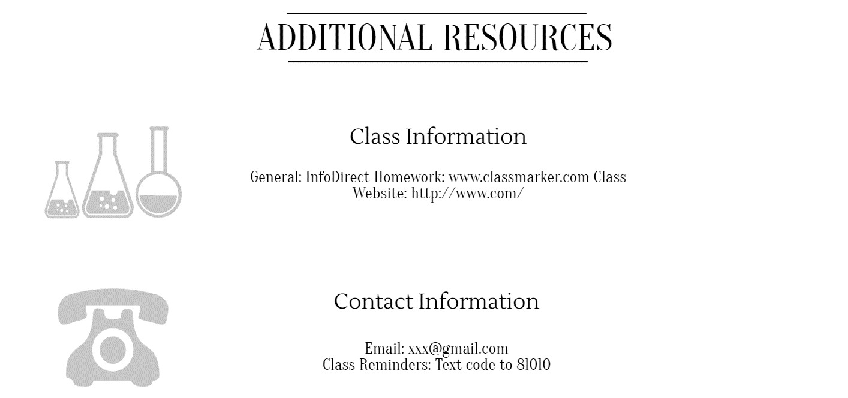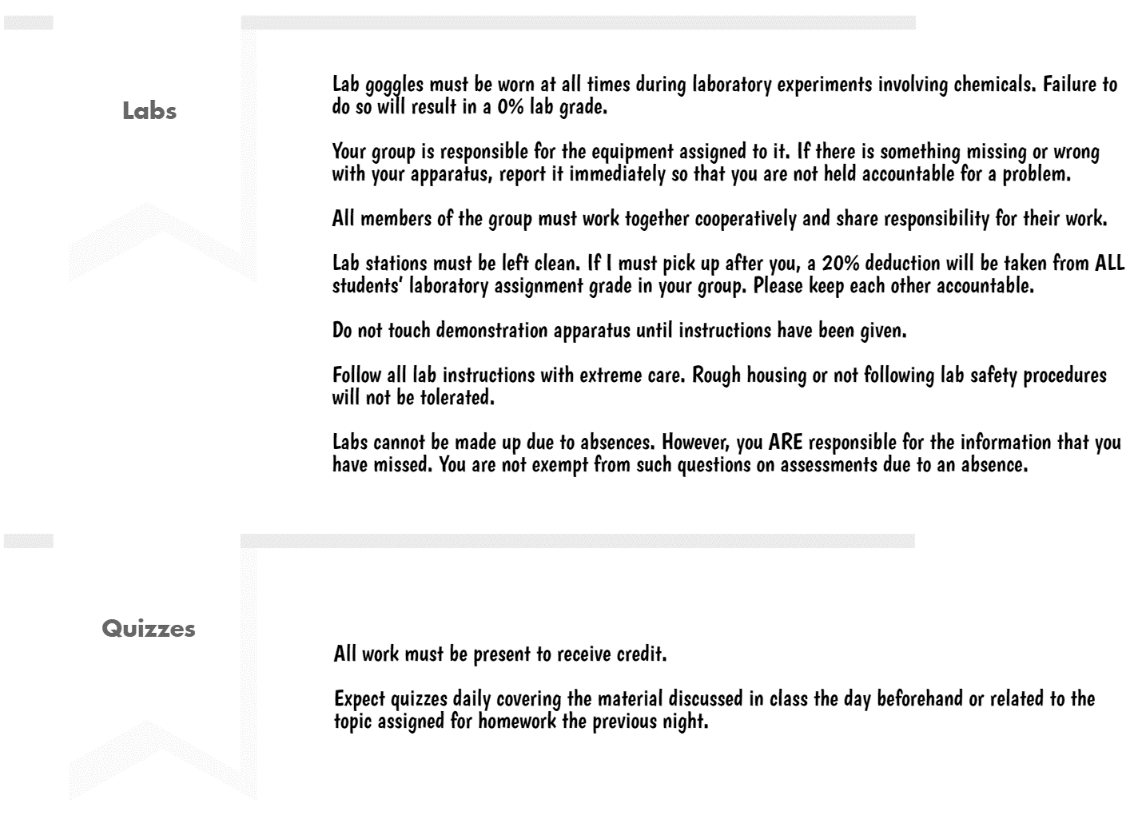

Email: yourclassroomhelper@gmail.com

Class Reminders: Text code to 81010

Social: @yourclassroomhelper

General: InfoDirect

Homework: www.classmarker.com

Class Website: www.yourclassroomhelper.com

ADDITIONAL RESOURCES

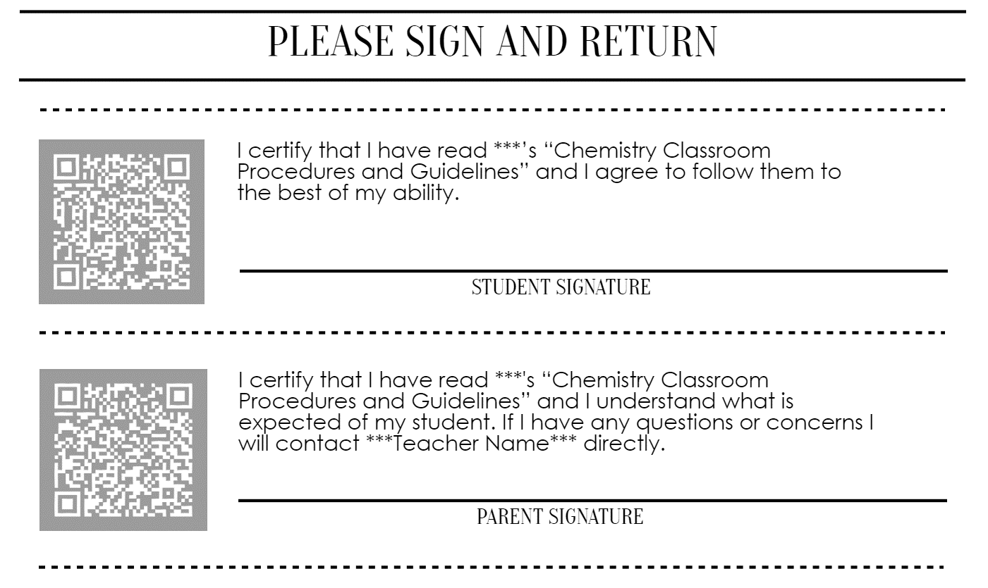

I certify that I have read \*\*\*Teacher’s name\*\*\*’s “Chemistry Classroom Procedures and Guidelines,” and I understand what is expected of my student. If I have any questions or concerns, I will contact \*\*\*Teacher’s Name\*\*\* directly.

I certify that I have read \*\*\*Teacher’s name\*\*\*’s “Chemistry Classroom Procedures and Guidelines,” and I agree to follow them to the best of my ability.

